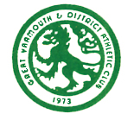
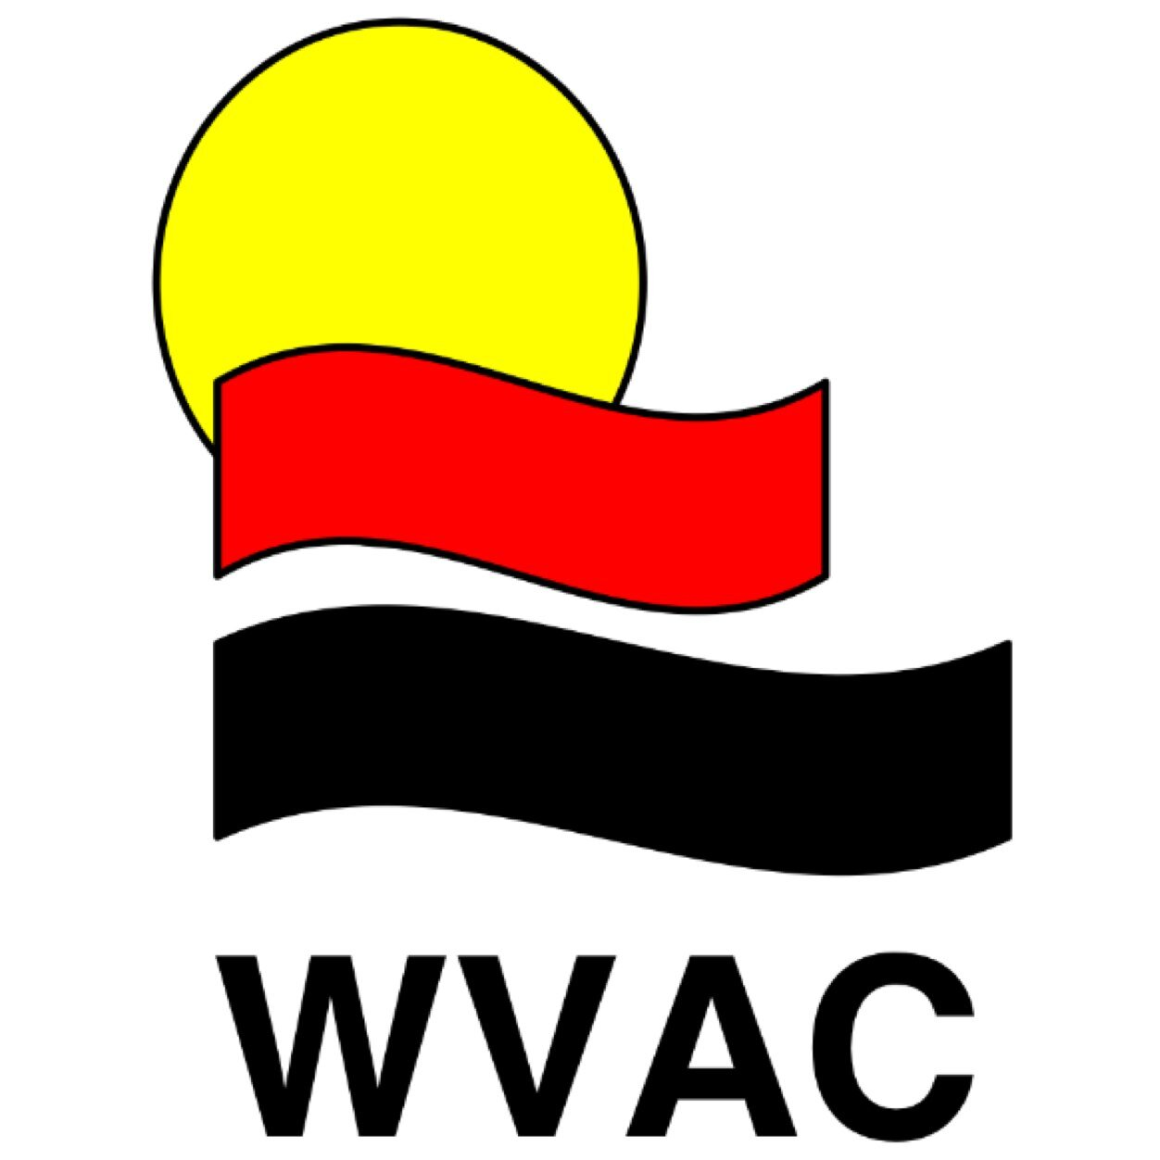

2015 Inter-Club Overall Team Winners

U11 Boys Race T&F XC SH Total Pos

WVAC 235 217 239 691 1st

FF 180 189 206 575 2nd

GYDAC 183 227 - 410 3rd

BBDRC 156 73 - 229 4th

U11 Girls Race T&F XC SH Total Pos

WVAC 85 46 240 371 3rd

FF 174 227 170 571 1st

GYDAC 184 142 46 372 2nd

BBDRC 129 - - 129 4th

U13 Boys Race T&F XC SH Total Pos

WVAC 205 234 191 630 1st

FF 140 208 138 486 2nd

GYDAC 95 50 - 145 4th

BBDRC 169 39 - 208 3rd

U13 Girls Race T&F XC SH Total Pos

WVAC 211 216 240 667 1st

FF 220 168 - 388 2nd

GYDAC 77 225 - 302 3rd

BBDRC 127 71 - 198 4th
2015 Inter-Club
Overall Club Winner

1st points WVAC - 2359

2nd points FF - 2020

3rd points GYDAC - 1229

4th points BBDRC - 764

