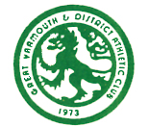
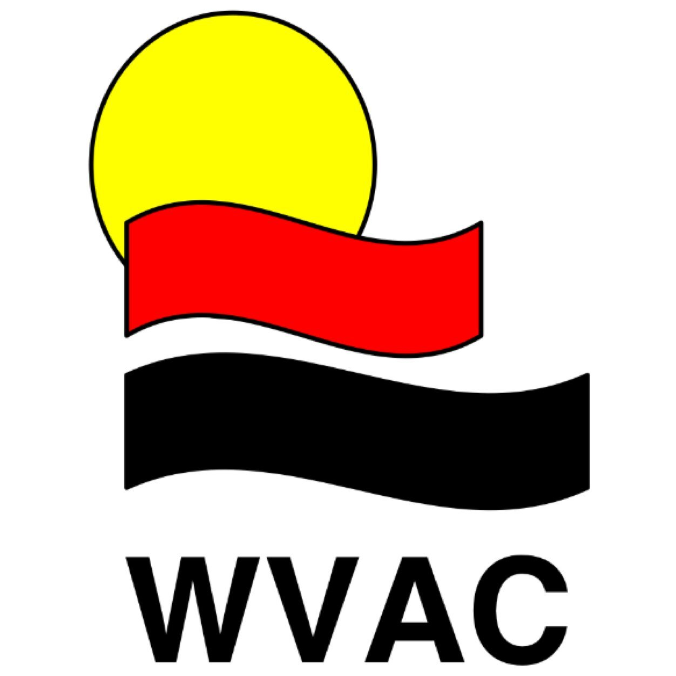

2017 Inter-Club Overall Team Winners

U11 Boys Race T&F XC SH Total Pos

WVAC 216 226 218 240 900 1

FF 197 211 218 165 791 2

GYDAC 63 148 42 104 357 4

BBDRC 177 48 47 77 349 5

BBH 123 69 150 57 399 3

U11 Girls Race T&F XC SH Total Pos

WVAC 108 164 47 89 408 4

FF 178 175 204 191 748 3

GYDAC 219 222 132 224 797 1

BBDRC 86 72 39 43 240 5

BBH 213 209 223 128 773 2

U13 Boys Race T&F XC SH Total Pos

WVAC 219 229 182 238 868 1

FF 174 177 226 47 624 2

GYDAC 162 125 - 42 329 3

BBDRC 45 - 50 44 139 4

BBH - - 48 - 48 5

U13 Girls Race T&F XC SH Total Pos

WVAC 45 139 - 175 359 4

FF 136 81 135 76 428 2

GYDAC 126 232 139 230 727 1

BBDRC 50 - 50 - 100 5

BBH 84 80 48 165 377 3

2017 Inter-Club
Overall Club Winner

points WVAC 2625 1st

points FF 2591 2nd

points GYDAC 2210 3rd

points BBH 1597 4th

points BBDRC 828 5th

